2022

Project



management

**The Ministry of Transport and the Ministry of Civil Aviation. Eng. Mohamed Ahmed Shaaban**

# Planning

Project name: Reservation of train and flight Tickets.

Project sponsor: the Ministry of Transport And the Ministry of Civil Aviation.

Project manager: Eng. Mohamed Ahmed Shaaban

The purpose of the project (Objective): to help citizens to travel inside and outside the borders of the country.

Business case: The application is used to help Citizens by booking train tickets and airline tickets And controlling congestion in reservation offices in Egypt.

The application also provides you with an Additional feature, which is to cancel the

Reservation and refund the value of the ticket Within 24 hours from the date of your purchase of The ticket.

If you want to buy a ticket to book a train or to Book a plane to travel to a specific country, you Will encounter some problems such as the Problem of overcrowding; whether traffic Congestion or congestion at the train station and Airline offices.

Other problems may result from the

Problem of overcrowding, such as: the spread of Diseases and epidemics, wasting a lot of time and Effort, and pressure on ticketing staff.

The application also helps in solving another problem, which is dealing with paper currencies, as

online payment will be a common element in the future.

Key deliverables of the project:

_The application allows the user to view all the Offers of the Ministries of Transport and Civil Aviation.

_The application also allows the user to book the Appropriate trip ticket for him, whether the trip is By train or by plane.

Project milestones (Timeline of Project): In the first two weeks, a team of web Engineers will do it gathering information about Tickets, their types and prices .For a week, the Engineers will design a website to promote the Project. For two weeks, a team of programmers

Will work Mobile application .The project is under

Testing for a week.

Project resources:

_ Receiver device

_Budget: $200,000.

_Work crew: A team of web engineers, Team of programmers.

_Salesman: Marketing companies and Internet marketplaces (such as Amazon, and Google Play)

Budget:

$200,000 (includes servers, project licenses, Developers, designers and training) Constraints:

1- The project should take less than 2months. 2- The project should not exceed $200,000.

3- Laptops and computers must be purchased From Dell.

Assumptions:

1- The project does not take more than 2 months. 2- The cost does not exceed $200,000.

3- Efficiency in hardware and ease of use of the Application.

High level risk:

1- Damage to the receivers. 2- Increase in cost.

1. **The lack of sufficient efficiency in the receiver Or the teams.**
2. **Failure to satisfy the users of the product. 5- The application has stopped working.**

(Scope statement)

**Product Description**: **The project is an application that provides a service for booking train and airline tickets online for travel within the country.**

**Also, this application is available for Android, Windows and Mac, where the customer can download the application through the organization's website for free.**

**The application provides a way to pay for the price of ticket.**

**Product Acceptance Criteria:**

* **The requirements that the application needs when booking a ticket are the phone number, name, credit**

**Card number, the station that the customer**

**wants to board from and the station that the customer wants to get off at.**

* **When the customer enters this data, the program will show a picture of a ticket that contains the customer's name, the ticket price, the station to which he will ride from, the station he will descend on, and the reservation confirmation code.**
* **A save button appears on the image when pressed, it saves the image with the client, and the phone number is used to send a reminder to the client an hour before traveling the ticket via credit card.**

**Project Deliverables: The project plan, reports, documents and resources that return to the company**, and **provide money, time,**

**space and human resources, and licenses and**

**authorities must be provided from the Ministry of Transport and the Ministry of Communications to start the project.**

**Project Exclusions: The idea of profit from the application and the site of the project should be excluded through advertisements, in order to provide a clear service without any confusion on the customer and so that the customer feels safe when dealing with the application.**

**Project Constraints: The constraints of the project are that the project must be implemented in no more than two months, and that the cost should not exceed $200,000,**

**and the rules and laws governing the company**

**must be established.**

**Project Assumptions:**

**-The application is designed to work on Windows, Android and IOS operating systems.**

* **The application is designed to work in both English and Arabic languages.**

**-The approval of the Ministry of Communications and Transport to implement the project.**

**…In the event that the previous assumptions are found to be false, it is possible that the project will be canceled.**

**(WBS)**

**Reservation of train and flight**



**Define requirement**

**Software Design**

**Testing**

* **Team communicati on arrangement**
* **Scope**
* **Risks**

**Budget and resources**

* **Coding**
* **Software engineer**

**- Website**

**Informatio n model**

**-Technical specificati on**

**-Platform**

**Programm ing language**

**-Testing code**

**-Testing design**

**(Responsibility Matrix)**

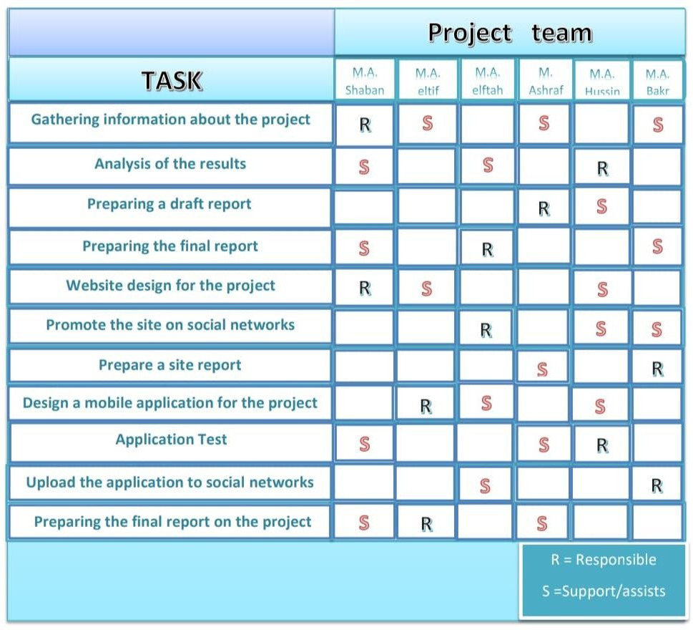

**(Network)**

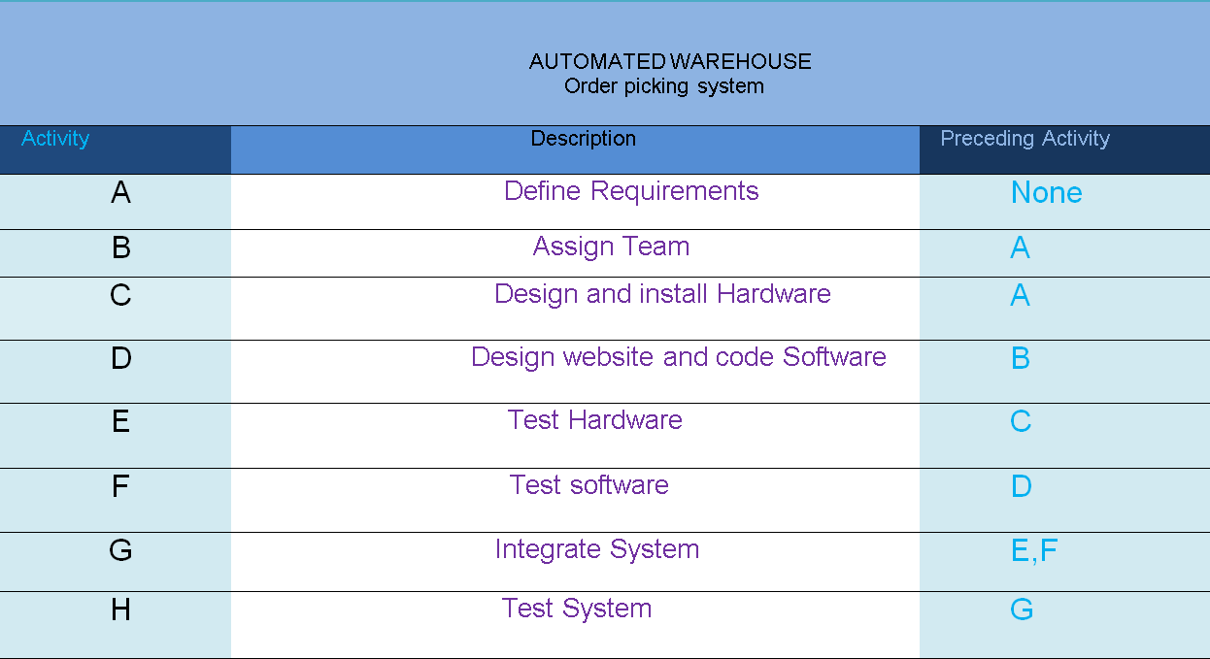

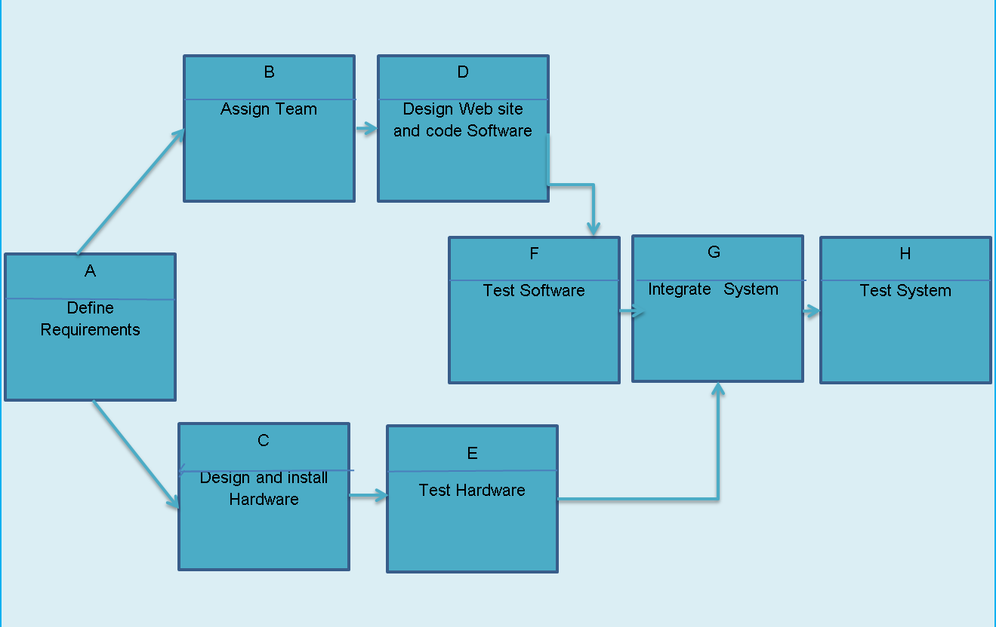

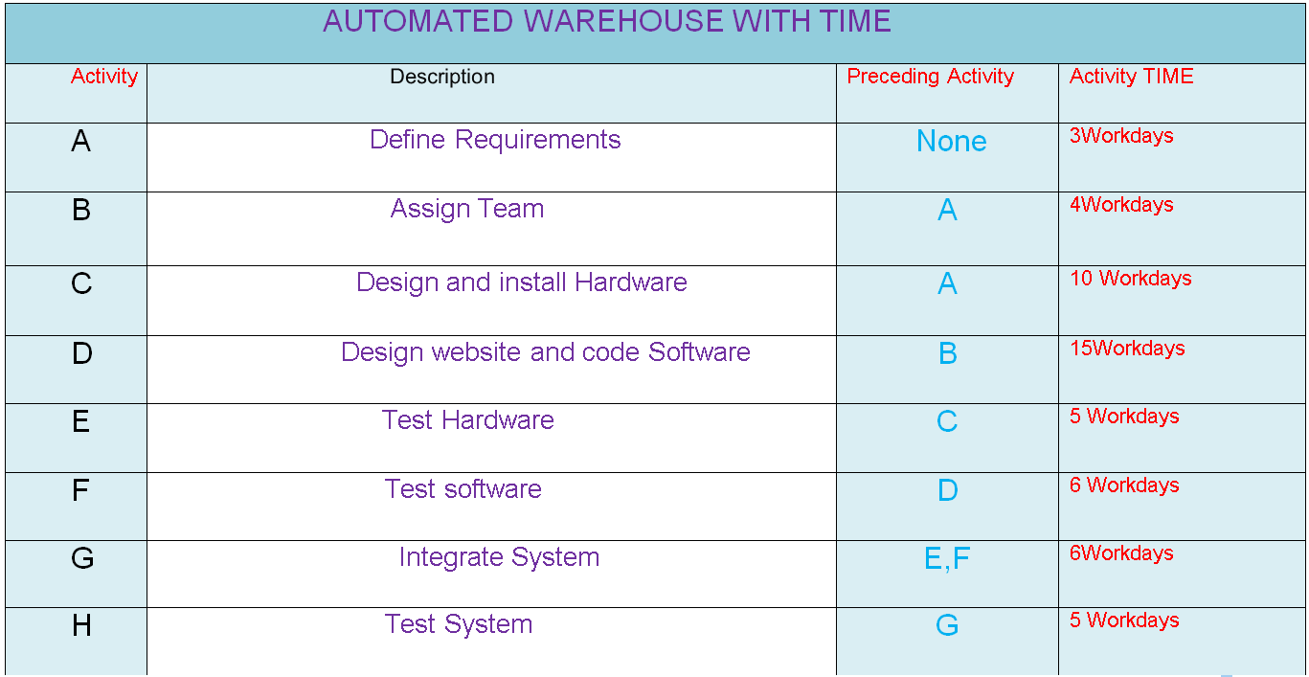

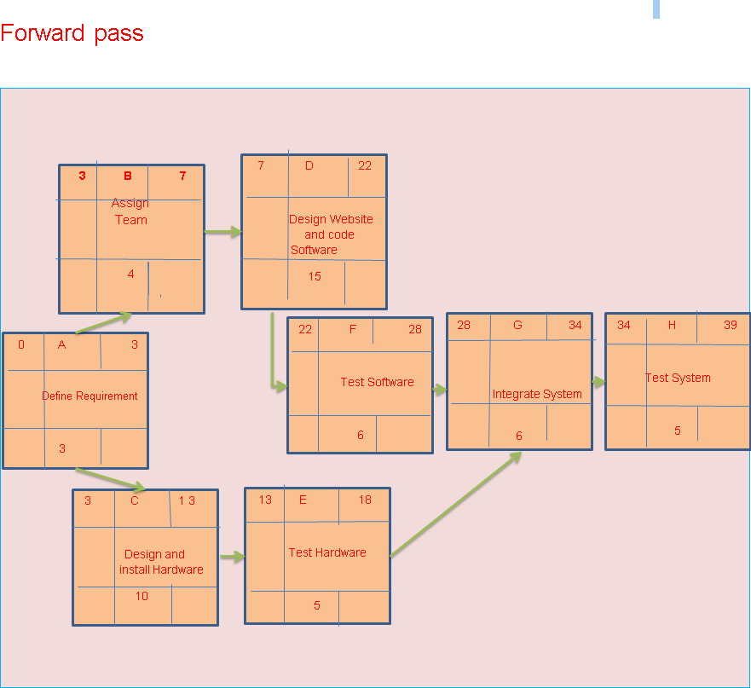

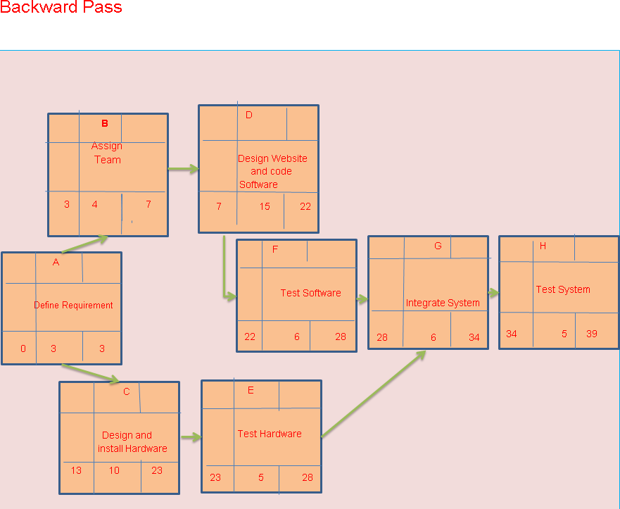

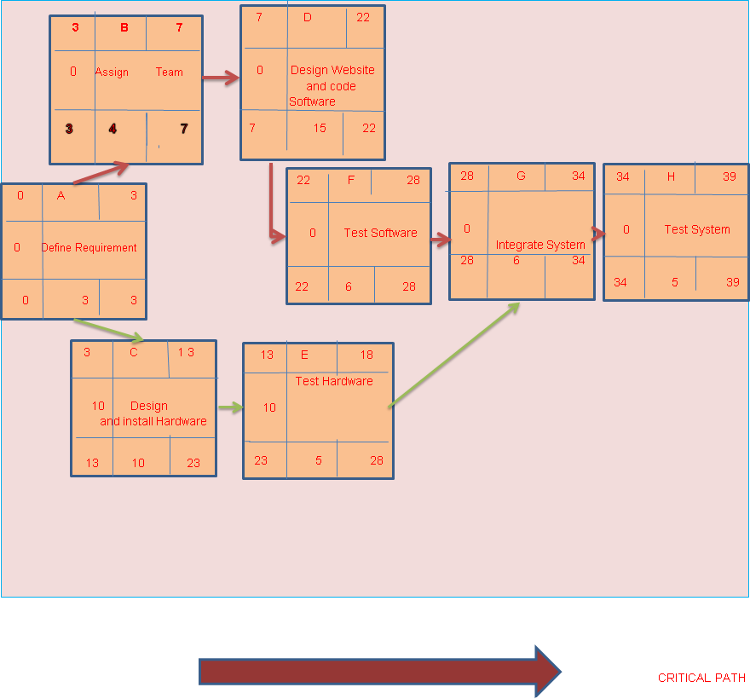

## (Gant Chart)



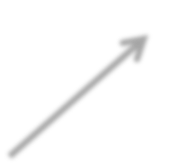

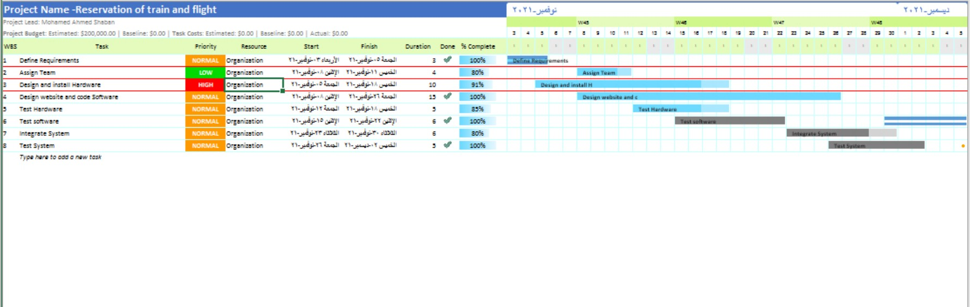

### (Resources)

|  |  |  |  |  |  |  |
| --- | --- | --- | --- | --- | --- | --- |
| 3 | B | 7 |  | 7 | D | 22 |
| 0 | 1p | 0 | 0 | 2p | 0 |
| 3 | 4 | 7 | 7 | 15 | 22 |

|  |  |  |
| --- | --- | --- |
| 0 | A | 3 |
| 0 | 3p | 0 |
| 0 | 3 | 3 |

|  |  |  |
| --- | --- | --- |
| 22 | F | 28 |
| 0 | 1p | 0 |
| 22 | 6 | 28 |

|  |  |  |
| --- | --- | --- |
| 28 | G | 34 |
| 0 | 3p | 0 |
| 28 | 6 | 34 |

|  |  |  |
| --- | --- | --- |
| 34 | H | 39 |
| 0 | 3p | 0 |
| 34 | 5 | 39 |

|  |  |  |  |  |  |  |
| --- | --- | --- | --- | --- | --- | --- |
|  | | | | 13 | E | 18 |
| 3 | C | 13 |  |
| 10 | 1p | 10 |
| 10 | 2p | 10 |
| 23 | 5 | 28 |
| 13 | 10 | 23 |
|  | | | |

0 3 7 13 18 22 28 34 39

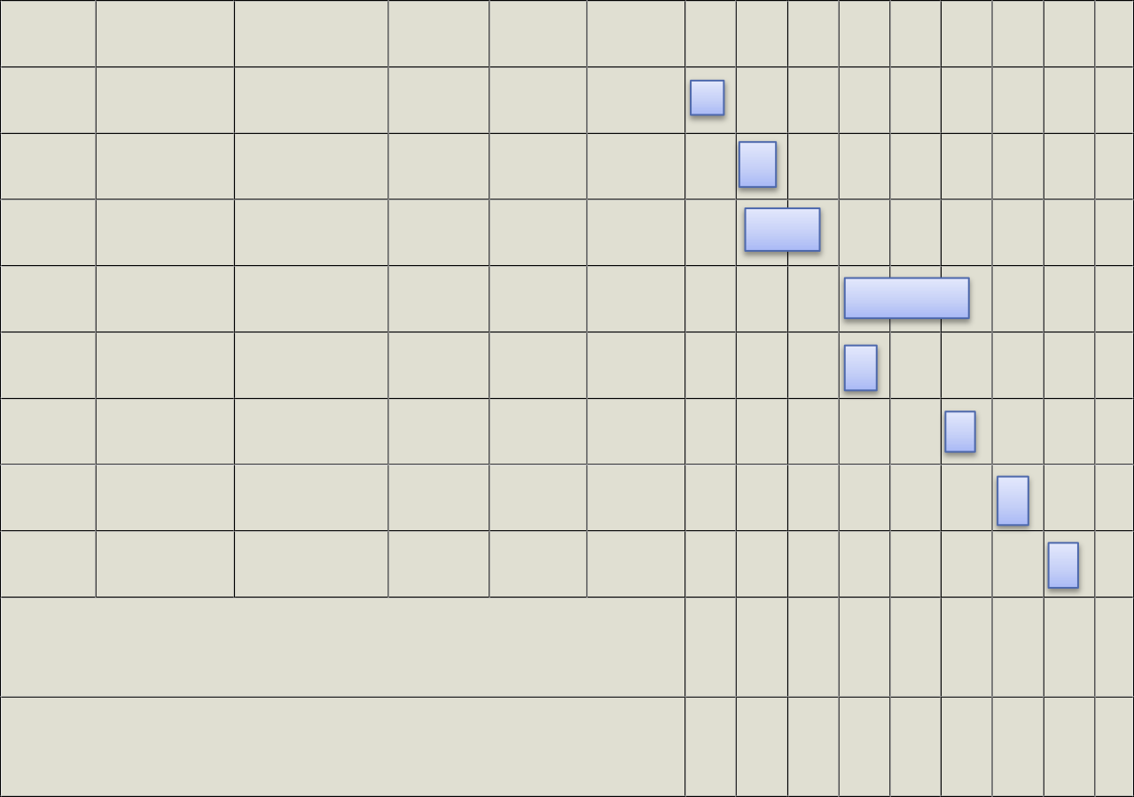ID RES DUR ES LS SL A 3P 3 0 0 0

B 1P 4 3 3 0

C 2P 10 3 13 10

D 2P 15 7 7 0

E 1P 5 13 23 10

F 1P 6 22 22 0

G 3P 6 28 28 0

H 3P 5 34 34 0

Resources scheduled Resources available

|  |  |  |  |  |  |  |  |
| --- | --- | --- | --- | --- | --- | --- | --- |
| 3 | 3 | 2 | 3 | 2 | 1 | 3 | 3 |
| 3 | 3 | 3 | 3 | 3 | 3 | 3 | 3 |

# (Budget)…

**(000$)**



0

3

7 13

18

22

|  |  |  |  |  |  |  |  |  |  |  |  |  |  |  |
| --- | --- | --- | --- | --- | --- | --- | --- | --- | --- | --- | --- | --- | --- | --- |
| Id | DUR | Task | Budget |  |  |  |  |  |  |  |  |  |  | |
| A | 3P | **Define Requirement** | 24 | 24 |  |  |  |  |  |  |  |  |  | |
| B | 1P | **Assign Team** | 12 |  | 12 |  |  |  |  |  |  |  |  | |
| C | 2P | **Design**  **and install Hardware** | 40 |  |  | 20 | 20 |  |  |  |  |  |  | |
| D | 2P | **Design**  **Website and code** | 60 |  |  |  |  | 20 | 20 | 20 |  |  |  | |
| E | 1P | **Test Hardware** | 60 |  |  |  |  | 60 |  |  |  |  |  | |
| F | 1P | **Test Software** | 12 |  |  |  |  |  |  | 12 |  |  |  | |
| G | 3P | **Integrate System** | 7 |  |  |  |  |  |  |  | 7 |  |  | |
| H | 3P | **Test System** | 7 |  |  |  |  |  |  |  |  | 7 |  | |
| Week total 222 | | | | 24 | 12 | 20 | 20 | 80 | 20 | 32 | 7 | 7 |  | |
| Cumulative | | | | 24 | 36 | 56 | 76 | 156 | 176 | 208 | 215 | 222 |  | |
| Cumulative 240  Baseline 200  Budget 160  (PV) 120  80  40 | | | |  |  |  |  |  |  |  |  |  |  | |
|  |  |  |  |  |  |  |  |  |  | |
|  |  |  |  |  |  |  |  |  |  | |
|  |  |  |  |  |  |  |  |  |  | |
|  |  |  |  |  |  |  |  |  |  | |
|  |  |  |  |  |  |  |  |  |  | |
|  |  |  |  |  |  |  |  |  |  |  |

**(The Risk)**

**-Development: the development process supported by a compatible set of procedures, methods, and tools.**

**-Schedule: dependent upon the completion of other projects**

**-Budget: the project is study by carful.**

**-Staffing: training staffing continue.**

**-Work Environment: people work cooperatively across functional boundaries.**

**-Quality: quality considerations built into the design.**

**-Technical Requirements: save equipment.**

**-Customer: the customer understand the project before we start work in project.**

**-Interruption of the Internet.**

**-hackers.**

**-One of our employee leave the company.**

**-Another competitive company make the same technology with better quality than us.**

**-Damage in the receivers.**

**-increase in the cost.**

**-The lack of efficiency sufficient in the receiver or the teams.**

**-Not to satisfy the users of product.**

**-Hardware. Positive risk:-**

**-There is only our company in the market.**

**-Make a change in company that may improve our technology.**

**-This application work The IOS and Android and windows operating system.**

**Project team**

#### Mohamed Ahmad Shaaban Ahmad

1. **Mohamed Ahmed Abdel Fattah Rashawn**

#### Mohamed Ahmed Abdel Latif Ali

1. **Mohamed Ahmed Hussein 5- Mohamed Ashraf Bakhit**

#### 6- Mohamed Abu Bakr Ibrahim Taha